**ABSTRACT**

This project focuses on developing a real-time construction crack monitoring system that combines machine learning and IoT technologies to enhance the safety and maintenance of construction sites. The system uses various sensor readings, including temperature, humidity, vibration, and accelerometer data, to predict the structural health of a construction site. Data preprocessing steps, such as handling missing values and calculating correlations between features, help in identifying key parameters that influence crack detection. Visualizations like histograms and heatmaps are used to understand the data distribution and feature relationships, guiding the feature selection process for accurate predictions.

The core of the system involves training two machine learning models—Random Forest and Gradient Boosting—to classify construction states as either "normal" or "cracked" based on sensor data. After encoding the target variable and scaling the features, the models are trained, evaluated, and optimized for real-time predictions. These trained models, along with the label encoder and scaler, are saved for deployment. The system is designed to continuously monitor and evaluate sensor data, ensuring high accuracy and reliability in detecting cracks.

To enable real-time monitoring, the system is integrated with the Blynk IoT platform, which fetches live sensor data through API calls. This data is then processed by the trained models to predict the presence of cracks, and the results are uploaded back to the platform for instant access. This system offers a proactive solution for construction site management, providing continuous crack detection, enabling timely maintenance actions, and ultimately ensuring safer, more efficient building practices.

**1. INTRODUCTION**

Construction crack monitoring is a fundamental aspect of maintaining the structural integrity of buildings. Cracks in buildings, if left undetected or untreated, can lead to severe consequences, including safety hazards, costly repairs, and even structural collapse. Traditional methods of crack detection often rely on manual inspections, which are time-consuming, prone to human error, and may not be able to provide real-time insights. As a result, there is an increasing demand for automated solutions that can continuously monitor construction sites, detect potential issues early, and provide timely alerts. This project leverages machine learning and IoT technologies to address these challenges and offer a more efficient and reliable method for construction crack monitoring.

The system collects real-time sensor data from various sources, including temperature, humidity, vibration, and accelerometer readings, to assess the structural condition of a construction site. By preprocessing the data and analyzing it with advanced machine learning algorithms, such as Random Forest and Gradient Boosting, the system can predict whether the construction site is in a stable state or if cracks are present. The use of data visualizations, including histograms and correlation heatmaps, helps to better understand the relationships between the sensor features, enabling more accurate predictions.

Machine learning models are trained on this processed data, and the target variable, representing the construction site's status (Normal or Crack), is encoded for classification. The models are then evaluated and fine-tuned to ensure high accuracy in crack detection. These models, along with the necessary label encoder and feature scaler, are deployed in the system to provide real-time predictions. The system is designed to automatically scale and process incoming data from the construction site, offering an always-on monitoring solution that can detect cracks and other structural issues instantly.

The integration of the Blynk IoT platform plays a crucial role in enabling real-time monitoring and remote access to the system. By fetching live sensor readings through API calls, the system continuously evaluates the construction site's health and provides immediate predictions. The results are uploaded back to the Blynk platform, allowing construction managers and maintenance teams to receive instant notifications and take corrective actions as needed.

**1.1 Project Overview**

The "Construction Crack Monitoring System" is an innovative solution that integrates Internet of Things (IoT) and machine learning technologies to detect and monitor cracks in construction structures in real time. The goal of this project is to provide a proactive approach to maintaining the structural integrity of buildings by utilizing sensor data to predict potential cracks and alert construction teams for immediate action. Traditional methods of crack detection often rely on manual inspections, which are labor-intensive and prone to human error. This system automates the process, ensuring continuous, real-time monitoring of construction sites and offering actionable insights to mitigate risks and reduce costly repairs.

At the core of the system are multiple sensors, including temperature, humidity, vibration, and accelerometer sensors, which continuously collect data from the construction site. This data is then processed and analyzed using machine learning algorithms, particularly Random Forest and Gradient Boosting classifiers, to predict whether the construction site is in a stable condition or if cracks are present. The target variable, indicating the status of the construction site (Normal or Crack), is encoded using a Label Encoder to facilitate classification.

The system uses Min-Max scaling to standardize the input data, ensuring that it is ready for training and testing of the machine learning models. After training the models on the historical sensor data, the system can classify new incoming data in real time, offering high accuracy in predicting the presence of cracks. The results are then displayed on the Blynk IoT platform, allowing remote monitoring and real-time alerts, which enable construction managers to take timely corrective actions. This integration with Blynk ensures that the system remains connected, providing continuous updates on the construction site’s health status.

In summary, this project offers a reliable, efficient, and automated solution for construction crack monitoring. It combines advanced machine learning models and IoT technology to provide accurate predictions, real-time monitoring, and immediate alerts, ultimately improving construction site safety, reducing maintenance costs, and enhancing the overall quality of construction management.

**2. OBJECTIVES**

**1. Real-Time Data Collection**

The system’s first objective is to gather real-time data from IoT sensors deployed on the construction site. These sensors collect data such as temperature, humidity, moisture, vibration, and accelerometer readings. This real-time data collection enables continuous monitoring of the site, ensuring that all environmental variables impacting the structure are tracked effectively.

**2. Data Preprocessing**

Once the sensor data is collected, it undergoes preprocessing to clean and format the data. This step includes handling missing data, normalizing the readings, and converting categorical data into numerical formats. The objective is to prepare the data for accurate analysis and machine learning modeling.

**3. Feature Selection and Engineering**

The next goal is to identify the most significant features from the raw data that directly influence the detection of cracks. This involves analyzing the relationships and patterns within the data, and extracting features that are relevant for detecting potential cracks, ensuring that the model works efficiently and accurately.

**4. Model Training with Machine Learning Algorithms**

Training machine learning models like Random Forest and Gradient Boosting is a critical objective. These models are trained using historical data, where instances of cracks are already known. The goal is for these models to learn the patterns associated with structural issues, enabling them to predict crack occurrences in real-time from sensor readings.

**5. Real-Time Crack Detection**

The primary objective is to utilize the trained models for real-time crack detection. As new sensor data is received, the models predict whether the construction site is safe or if a crack is likely. This provides immediate feedback for swift action, minimizing the risk of unaddressed structural damage.

**6. Integration with Blynk IoT Platform**

To enhance remote monitoring, the system integrates with the Blynk IoT platform. This allows construction managers to view real-time data and crack detection results on a cloud-based interface, providing flexibility and instant access to site conditions, even from remote locations.

**7. Real-Time Alerts and Notifications**

In cases where cracks or abnormalities are detected, the system sends instant alerts via the Blynk platform. This proactive alert system ensures that construction managers are notified as soon as a problem arises, enabling immediate inspection or intervention to prevent further structural damage.

**8. Scalable and Adaptive System**

Another important goal is to design a system that can scale and adapt to different types of construction projects, from small buildings to large infrastructure. Whether the site uses a handful of sensors or a comprehensive array, the system should be flexible enough to accommodate different sensor setups and varying project needs.

**9. Visualizations for Easy Interpretation**

To make the data more interpretable, the system provides visualizations like graphs, histograms, and heatmaps. These visual representations allow construction managers to quickly understand trends, anomalies, and sensor behavior, making it easier to assess the condition of the construction site and take the necessary steps.

**10. Cost Reduction and Efficiency Improvement**

Ultimately, the system aims to reduce maintenance costs by enabling early detection of cracks and structural issues. By monitoring the construction site continuously, predicting cracks, and automating the detection process, the system reduces the need for manual inspections, leading to cost savings and improved overall efficiency in managing the construction project.

### ****2.1 Scope of the Construction Crack Monitoring System****

1. **Real-Time Monitoring and Data Collection**  
   The system integrates IoT sensors on the construction site to continuously gather real-time data. Sensors such as temperature, humidity, moisture, vibration, and accelerometers monitor environmental conditions that may affect the structural integrity of the building. This ensures constant, uninterrupted data collection for ongoing site monitoring.
2. **Predictive Maintenance and Crack Detection**  
   After gathering the data, machine learning models like Random Forest and Gradient Boosting are used to analyze it. The system identifies patterns that may indicate the formation of cracks or structural weaknesses. This predictive maintenance feature helps prevent sudden failures by providing insights into future problems based on past data trends.
3. **Remote Monitoring via IoT Platform**  
   The construction team can remotely monitor the construction site using platforms like Blynk. This allows for real-time data visualization, eliminating the need for constant on-site supervision. Remote monitoring improves efficiency, ensuring that site conditions are always under control, even when supervisors are off-site.
4. **Real-Time Alerts and Notifications**  
   If any anomaly or potential crack is detected, the system sends immediate alerts to the construction team. This real-time notification system enables quick action, allowing the team to address issues as soon as they arise, preventing delays and potential damage.
5. **Data Visualization and Reporting**  
   The system incorporates powerful data visualization features to convert complex sensor data into easy-to-understand charts, graphs, and heatmaps. These visual tools assist construction managers in quickly interpreting large datasets, making it easier to make informed decisions. Detailed reports can also be generated and shared with stakeholders.
6. **Scalability and Customization**  
   The system is designed to be scalable and adaptable to various construction projects. Whether it’s a small-scale building or a large infrastructure project, additional sensors can be added as needed. The system can be customized to monitor specific factors relevant to the project, enhancing flexibility.
7. **Cost Reduction and Increased Efficiency**  
   By automating the monitoring process, the system reduces the need for manual inspections, which saves both time and money. The system increases efficiency by focusing resources on areas where potential issues are detected, preventing unnecessary inspections and costly repairs.
8. **Preventive Action and Long-Term Maintenance**  
   One of the primary advantages of the system is its ability to detect early signs of cracks or other structural issues, allowing for preventive action. By identifying potential problems before they escalate, the system helps prolong the lifespan of the building and reduces the likelihood of expensive repairs in the future.
9. **Enhanced Safety and Risk Management**  
   Continuous monitoring ensures the safety of the construction site by identifying risks related to structural integrity. In the event of a potential issue, the system triggers alerts to notify safety personnel, who can then take appropriate action. This proactive approach helps reduce accidents and improve overall safety on the site.
10. **Integration with Other Construction Management Tools**  
    The system is designed for seamless integration with other construction management tools, such as scheduling, resource management, and budgeting software. This integrated approach improves coordination among different teams and departments, streamlining the entire project workflow and making it easier to manage.

**2.2 Modules**

* 1. Data Acquisition Module
  2. Preprocessing and Data Cleaning Module
  3. Feature Engineering and Selection Module
  4. Machine Learning Model Training Module
  5. Prediction Module
  6. Alert and Notification Module
  7. Data Visualization and Reporting Module
  8. Remote Monitoring Module
  9. Maintenance and Diagnostics Module
  10. Integration Module

**2.4 Modules Descriptions**

1. **Data Acquisition Module**
   * **Description:** This module is responsible for collecting real-time data from IoT sensors placed at various points on the construction site. These sensors monitor parameters such as temperature, humidity, vibrations, and other environmental factors that could affect the structural integrity of the building. Data from these sensors is continuously streamed to a centralized system for processing and analysis.
2. **Preprocessing and Data Cleaning Module**
   * **Description:** This module ensures that the raw data collected from sensors is cleaned and prepared for analysis. It removes any inconsistencies, such as missing or erroneous values, and normalizes the data to ensure uniformity across all measurements. This process ensures that the machine learning models trained on the data can make accurate predictions and classifications.
3. **Feature Engineering and Selection Module**
   * **Description:** In this module, new features are created from the raw sensor data, potentially improving the predictive power of the machine learning models. The module selects the most relevant features for training the models, ensuring that only the most important information is used. This helps optimize the model’s performance and avoids overfitting.
4. **Machine Learning Model Training Module**
   * **Description:** This module is where the machine learning models are trained using the cleaned and preprocessed data. The models, such as Random Forest and Gradient Boosting, are trained to recognize patterns associated with potential structural cracks in the construction. Hyperparameter tuning and cross-validation are performed to achieve the best results in terms of accuracy and reliability.
5. **Prediction Module**
   * **Description:** After training, the machine learning models are applied to incoming sensor data to predict whether the construction site is at risk of developing cracks. The prediction module processes the new data and outputs a classification (e.g., "normal" or "crack detected"). This real-time prediction allows for immediate monitoring and intervention.
6. **Alert and Notification Module**
   * **Description:** Once a crack or potential structural issue is detected, this module sends out alerts to the appropriate personnel. Alerts can be delivered through various channels, such as SMS, email, or mobile notifications, ensuring that construction managers and engineers can take prompt action to prevent further damage.
7. **Data Visualization and Reporting Module**
   * **Description:** This module converts the collected data and the results of predictions into visual formats such as graphs, charts, and dashboards. It provides a user-friendly interface for construction teams and stakeholders to analyze trends, identify potential risks, and make informed decisions based on the data. It also generates detailed reports summarizing system performance and findings.
8. **Remote Monitoring Module**
   * **Description:** This module enables remote monitoring of the construction site through a web or mobile interface. By connecting the system to an IoT platform, construction managers can view real-time data, alerts, and system performance from any location. It provides flexibility and ensures that site conditions can be monitored continuously, even when not on-site.
9. **Maintenance and Diagnostics Module**
   * **Description:** To ensure the system remains reliable, this module monitors the health of both hardware and software components. It provides diagnostics for issues such as malfunctioning sensors or degraded model performance, alerting the team when maintenance is required. This helps maintain the system’s accuracy and functionality over time.
10. **Integration Module**

* **Description:** This module ensures that the Construction Crack Monitoring System integrates smoothly with other systems in place at the construction site. It facilitates the exchange of data with other construction management tools, such as scheduling software or resource planning systems. This seamless integration streamlines operations and ensures that relevant data is available to all necessary stakeholders.

**Data Flow Diagram:**

**Level 0:**

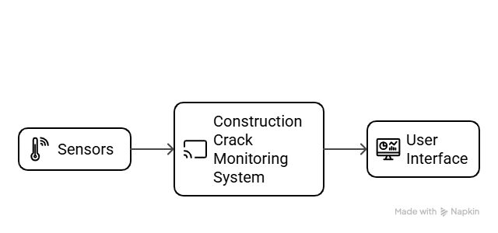

**Level 1**

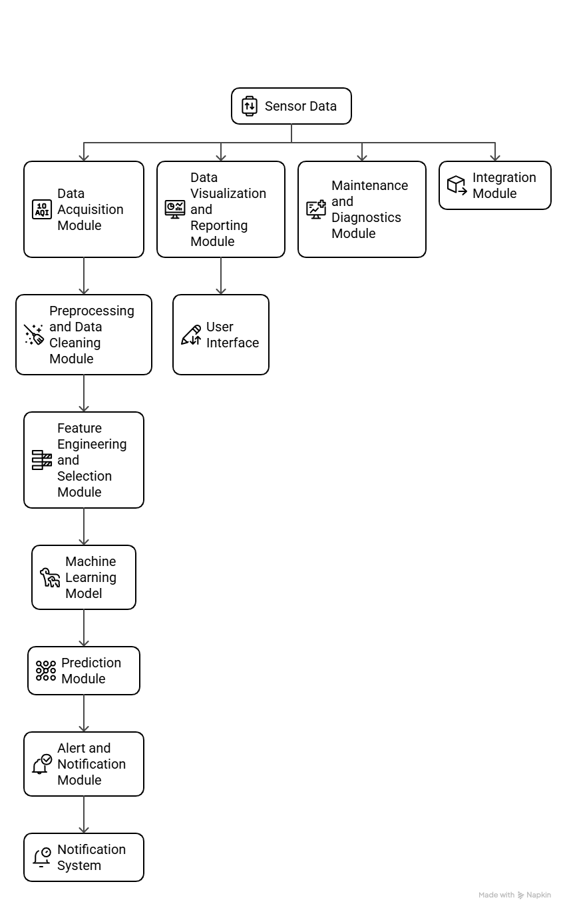

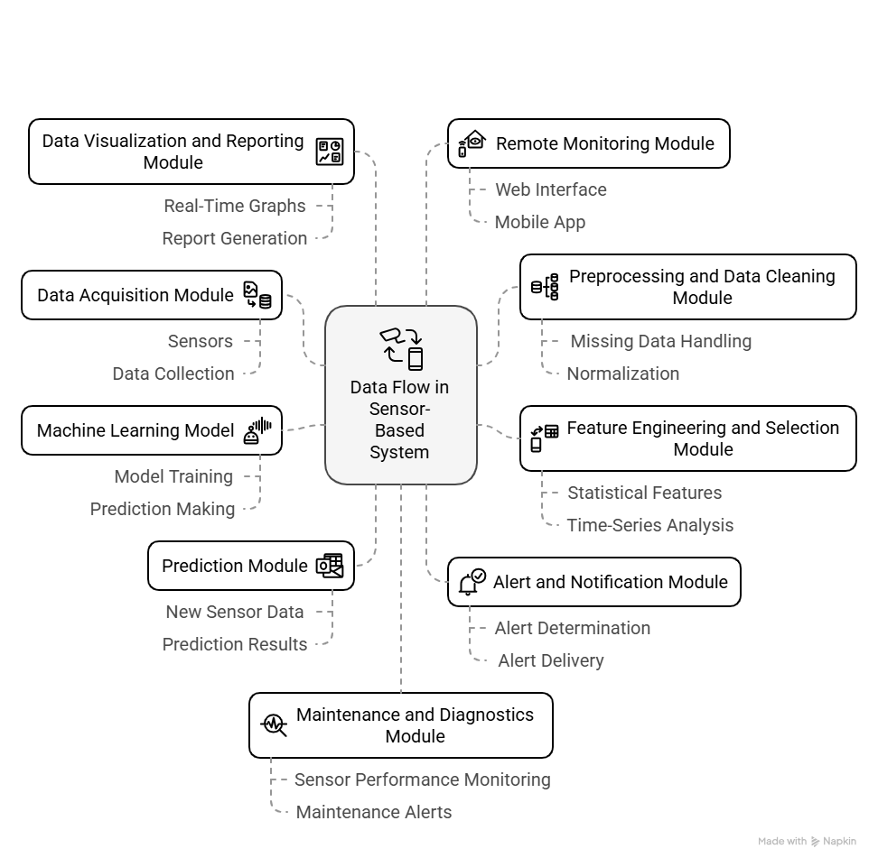

### ****Conclusion****

The **Construction Crack Monitoring System** is a highly innovative and efficient solution for ensuring the structural integrity of construction projects. By leveraging IoT technologies, machine learning, and real-time data analytics, the system is able to predict and identify potential cracks in construction materials before they become critical, thereby preventing costly damage and enhancing safety. The integration of environmental sensors, predictive models, and user-friendly interfaces makes this system invaluable for construction engineers and managers who aim to maintain high standards of safety and quality in their projects.

Through continuous monitoring of environmental factors such as temperature, humidity, and vibrations, the system collects essential data that is processed and analyzed using advanced machine learning techniques. This proactive approach not only helps in detecting cracks early but also assists in understanding the underlying factors that contribute to material deterioration. The system's ability to generate alerts and visualize data in real-time ensures that users can take immediate action when needed, leading to more effective decision-making and timely interventions.

In conclusion, the **Construction Crack Monitoring System** offers immense value to the construction industry by reducing the risk of structural failures and improving the overall efficiency of project management. As construction projects grow in scale and complexity, systems like this will play an increasingly crucial role in monitoring and maintaining safety standards. With further advancements in sensor technology and machine learning, the system has the potential to evolve into an even more sophisticated tool for predictive maintenance and monitoring, ensuring that construction remains both safe and sustainable.

Top of Form

Bottom of Form